|  |  |
| --- | --- |
| Course Name | ITD 3243 – Server Side Programming |
| Instructor | Mark L. Pranger |
| Student Name | Derrick McFall |
| Due date | 13Feb19 |
| Grade | <grade earned here> |
| Grading Comments | <instructor comments here> |

Module 6

Book Exercise 8-1

1. Run the application in the ex_starts/ch08_ex1 directory. Then, test this application by entering either “R” or “C” in the Customer Type box and a value from 0 to 500 in the Invoice Subtotal box. When you click on the Calculate button, you can see that the discount percent is based on both the customer type and subtotal amount.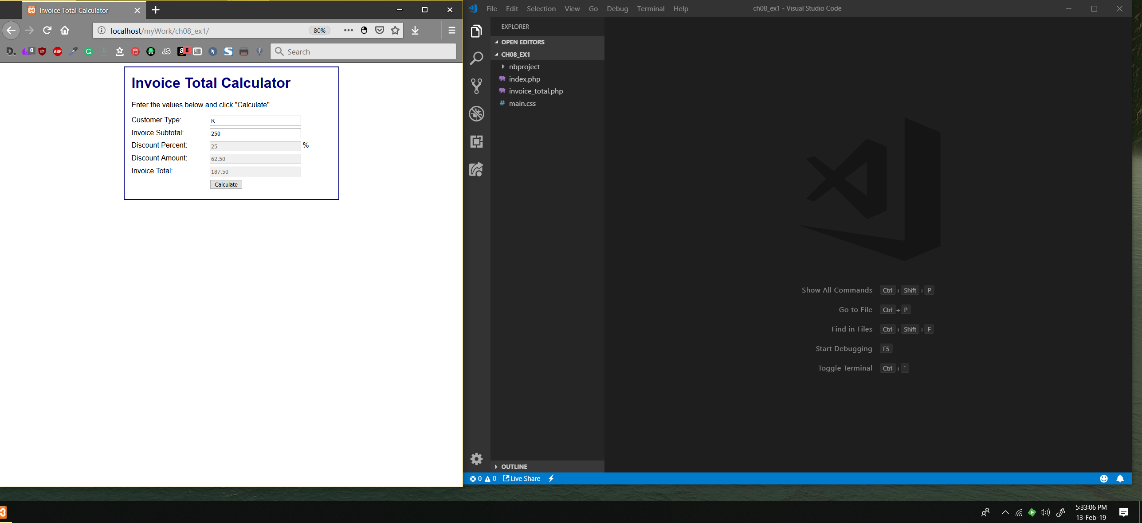

2. Open the index.php and invoice_total.php files for this application and review the code. Note that this code uses nested if statements to determine the discount percent.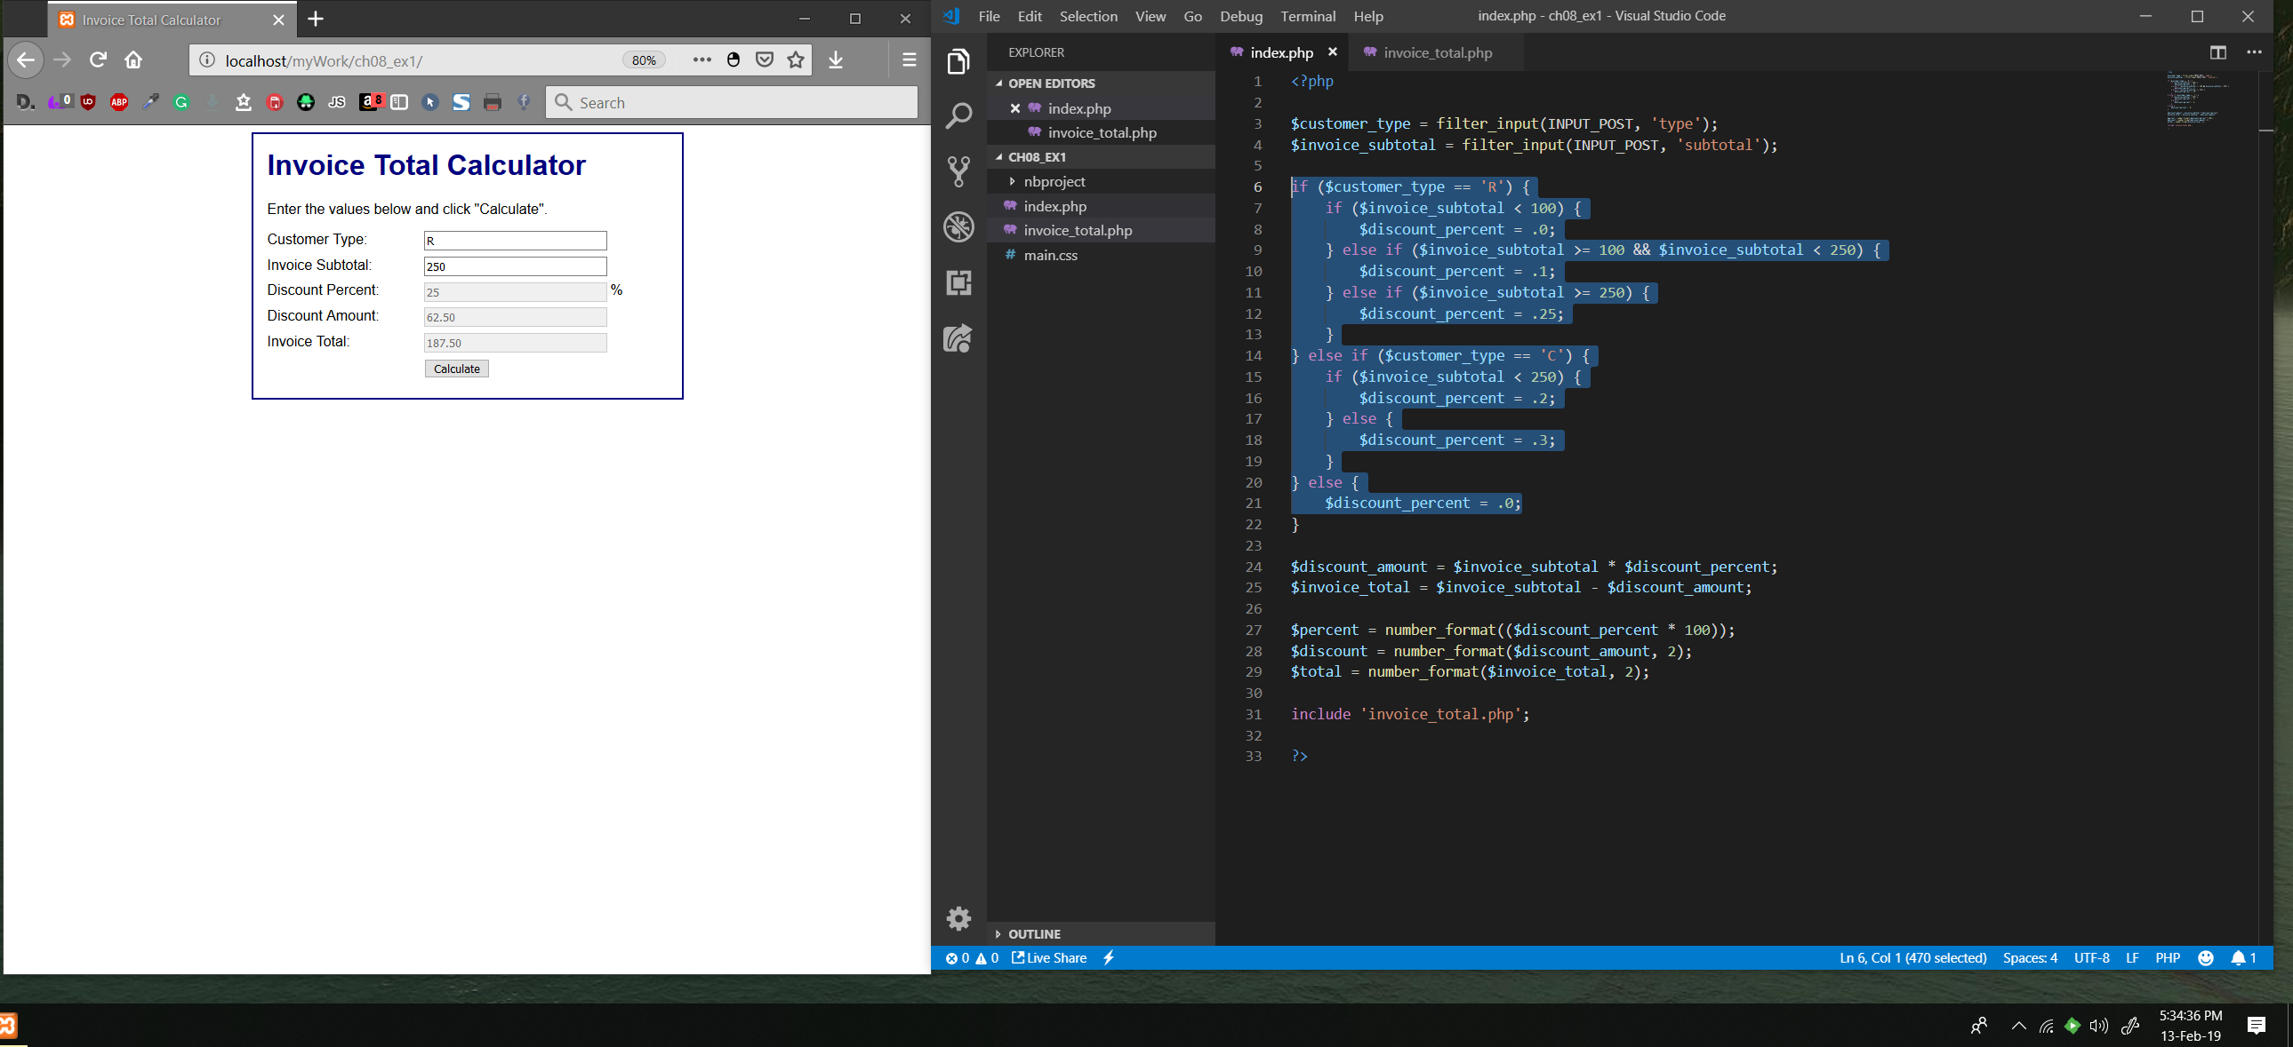

**Change the code that determines the discount percent**3. Change the if statement so customers of type R with a subtotal that’s greater than or equal to $250 but less than $500 get a 25% discount and those with a subtotal of $500 or more get a 30% discount. Next, change the if statement so customers of type C always get a 20% discount. Then, test these changes.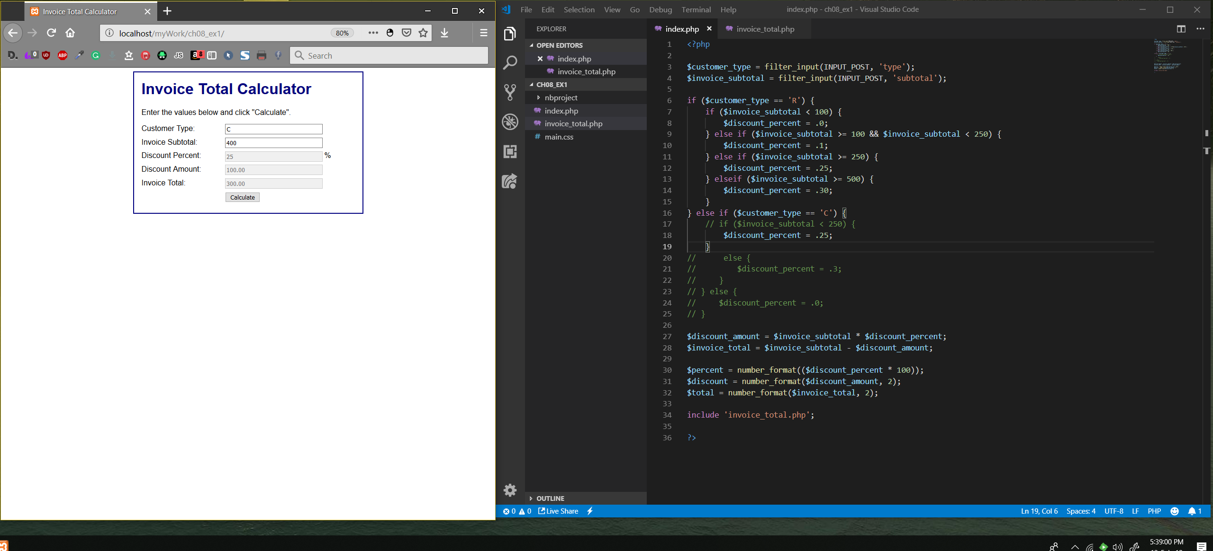

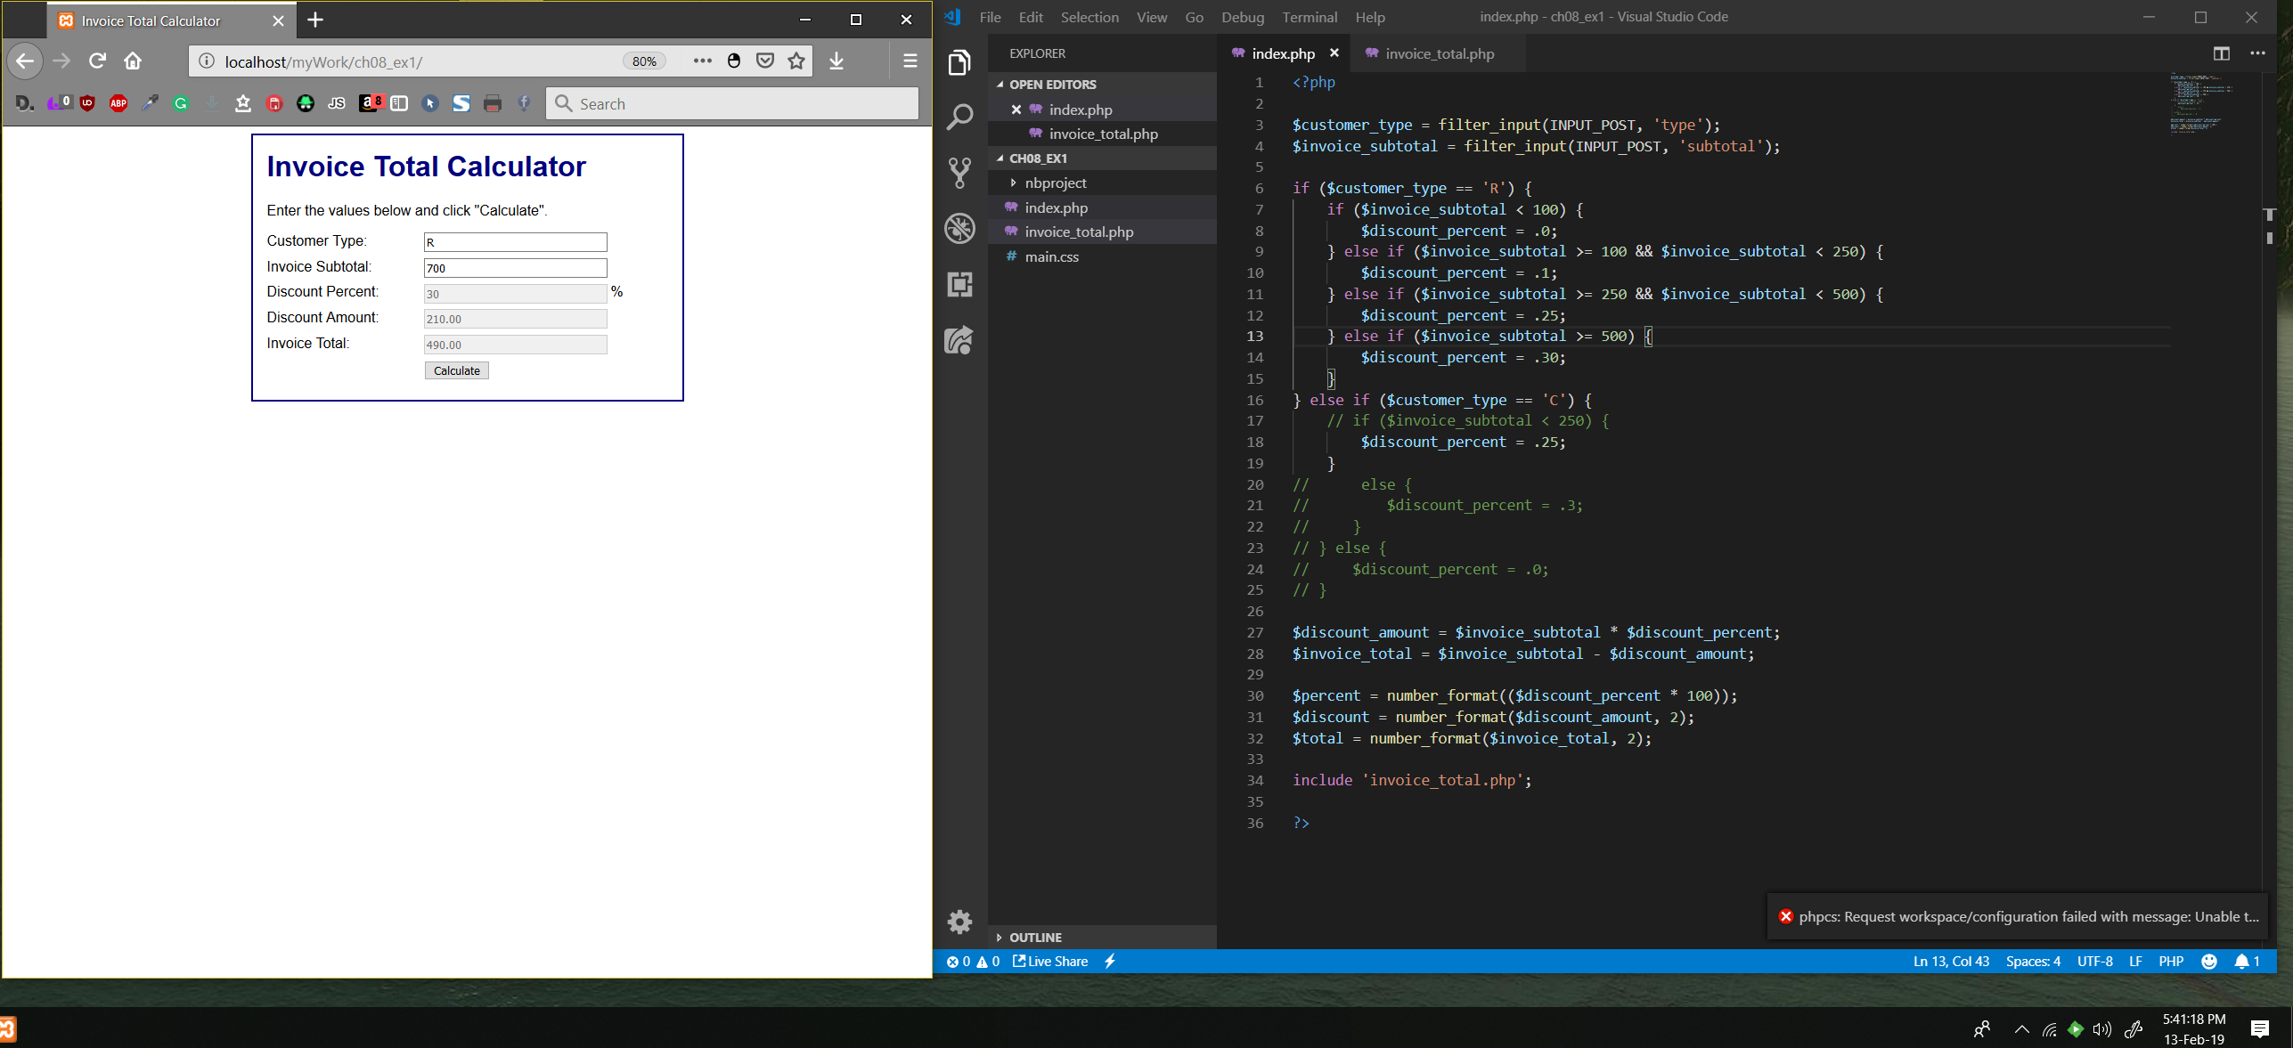

4. Add another type to the if statement so customers of type T get a 40% discount for subtotals of less than $500, and a 50% discount for subtotals of $500 or more. Also, make sure that customer types that aren’t R, C, or T get a 10% discount. Then, test these changes.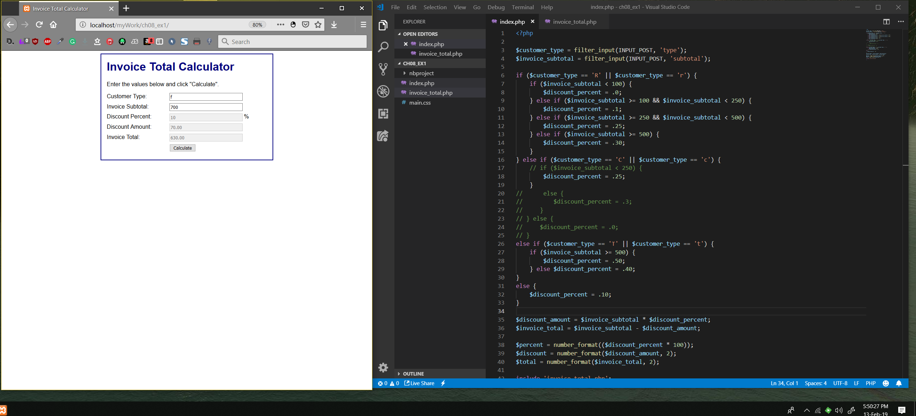

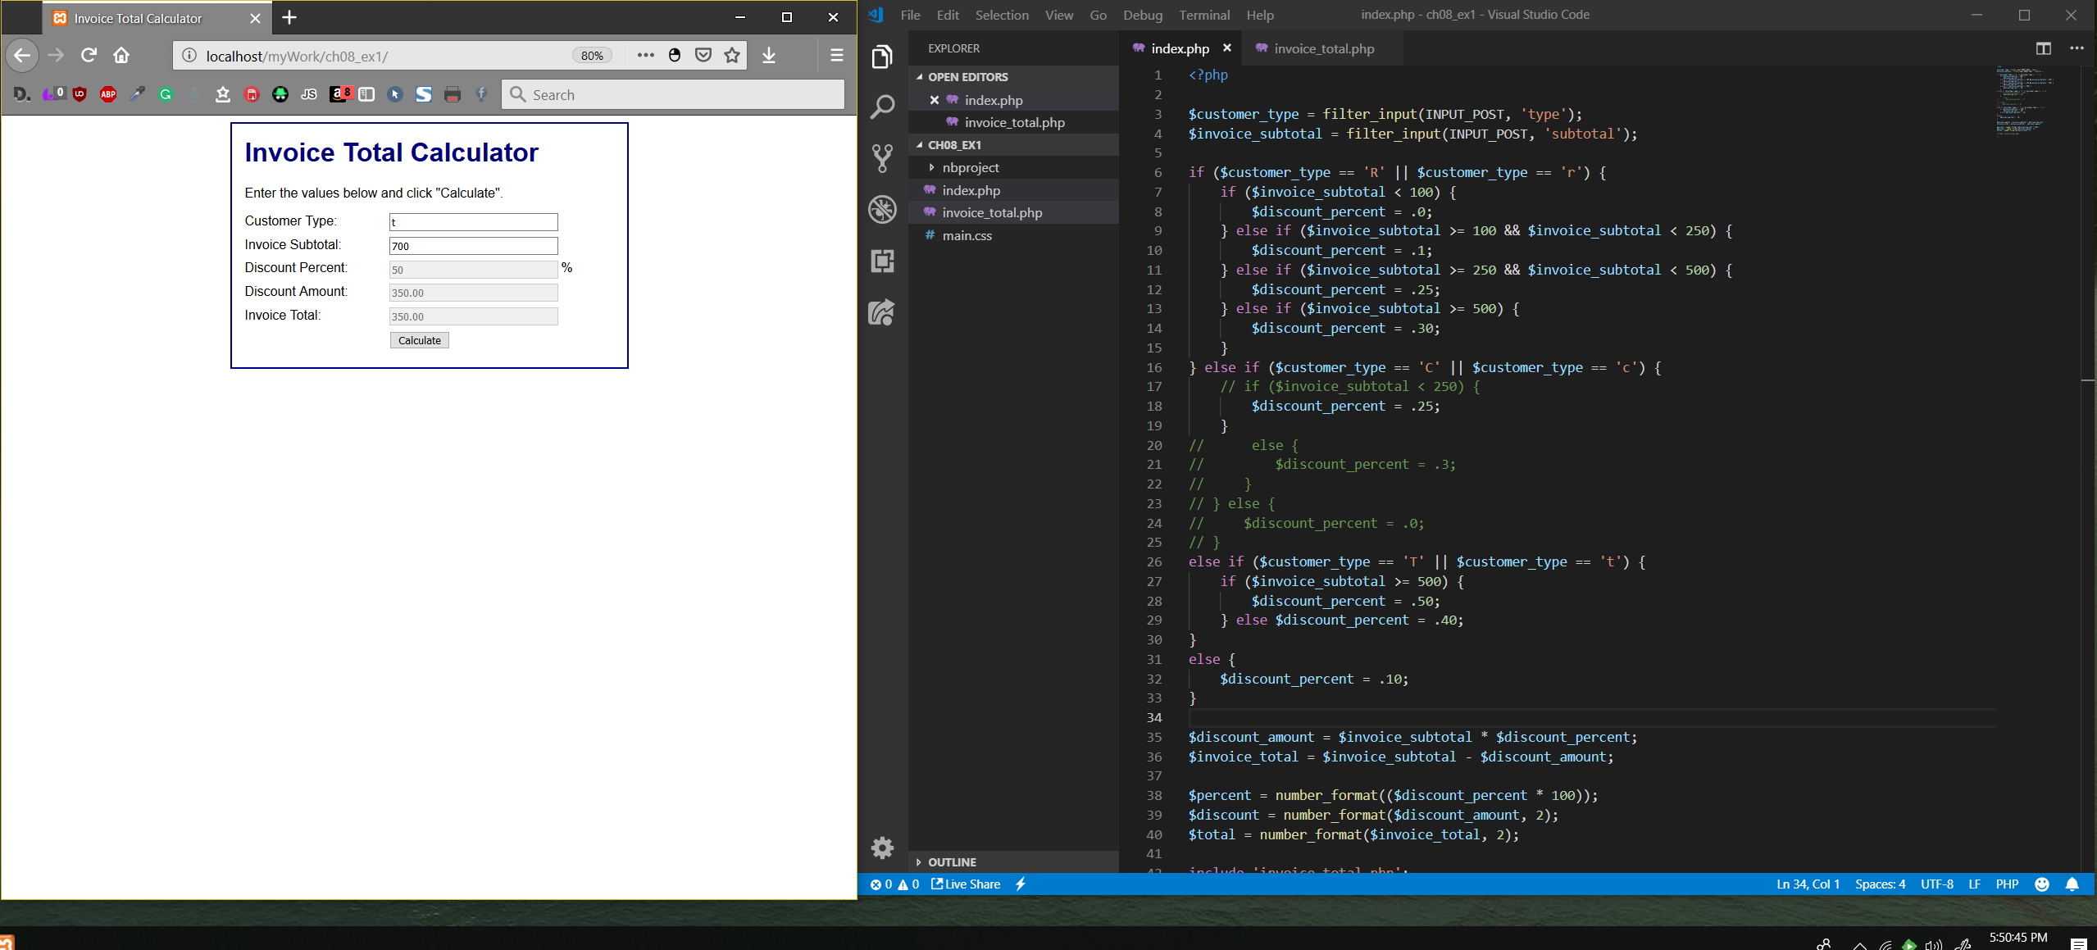

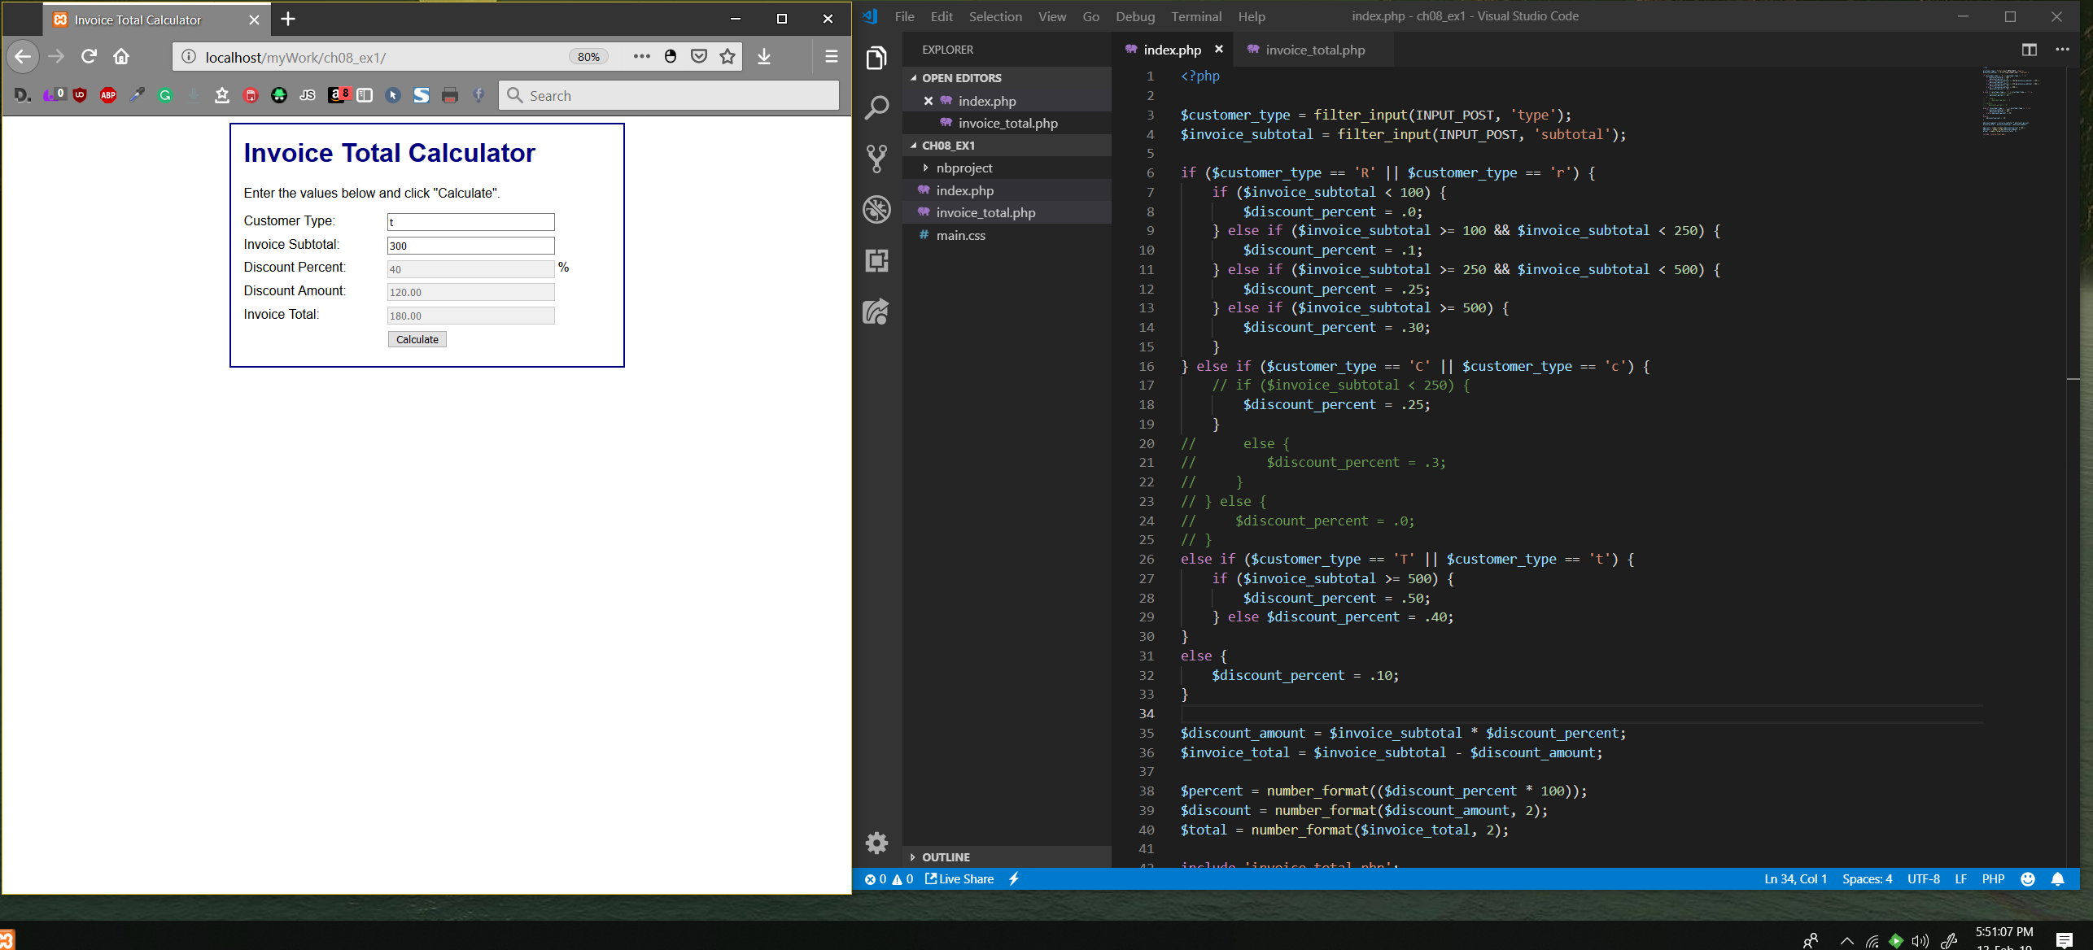

5. Test the application again, but use lowercase letters for the customer types. Note that these letters aren’t evaluated as capital letters.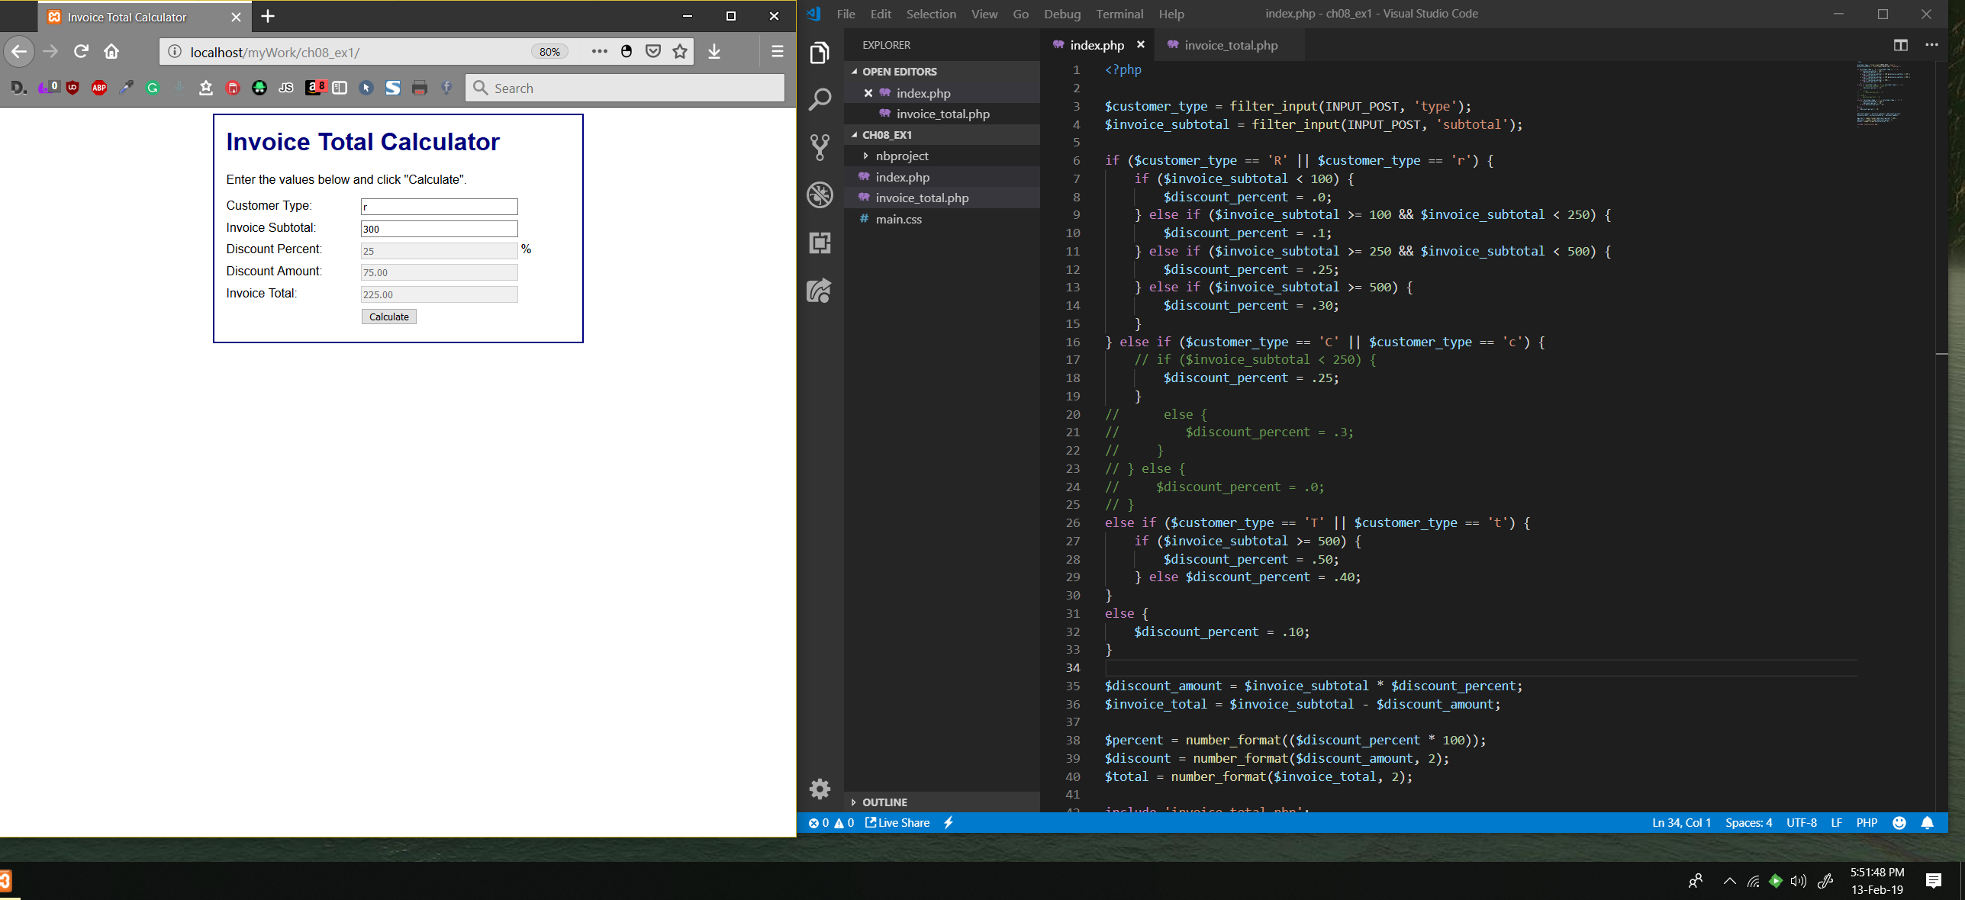

This was the first thing I fixed because I don’t like not being able to use lowercase letters.

6. Modify the code so the users can enter either capital or lowercase letters for the customer types. To do that, use logical operators. Then, test this change.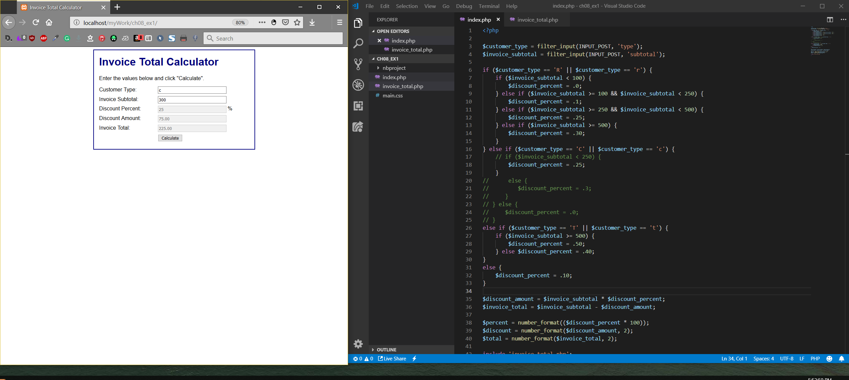

**Use a switch statement with nested if statements to get the same results**

7. Code a switch statement right before the if statement. This statement should provide the structure for handling the three cases for customer types: R, C, and T. Then, within each of these cases, you can copy the related code from the if statement to provide for the discounts that are based on subtotal variations. In other words, you can nest the if statements within the switch cases.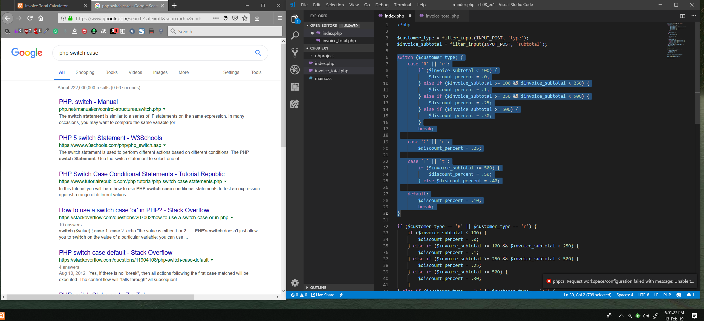

8. Comment out the entire if statement that’s below the switch statement. Then, test to make sure the switch statement works correctly.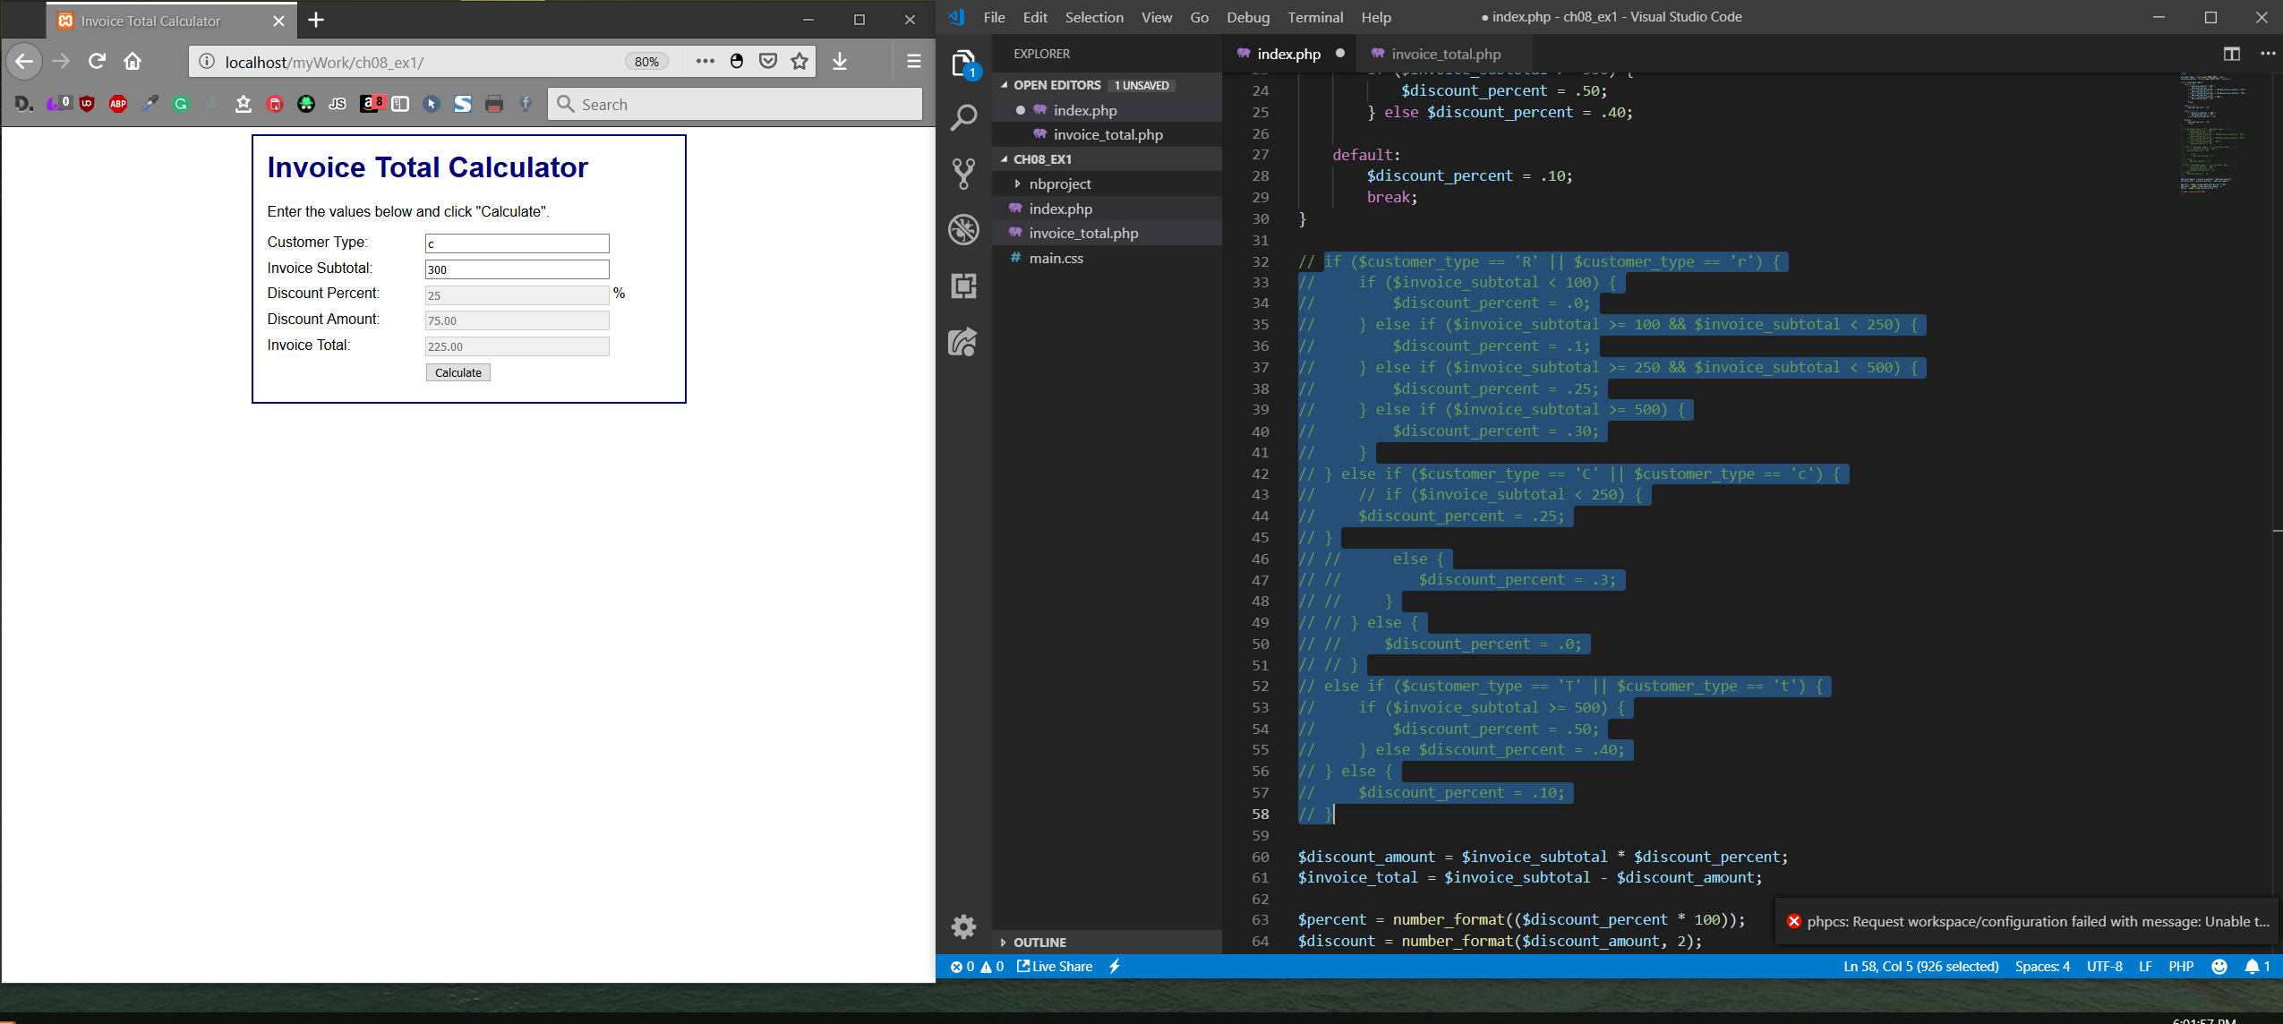

9. If you haven’t done so already, modify the switch statement so it works for both lowercase and uppercase entries of the three customer types. To do that, add case labels for the lowercase entries that fall through to the case labels for the uppercase entries. Then, test that change.

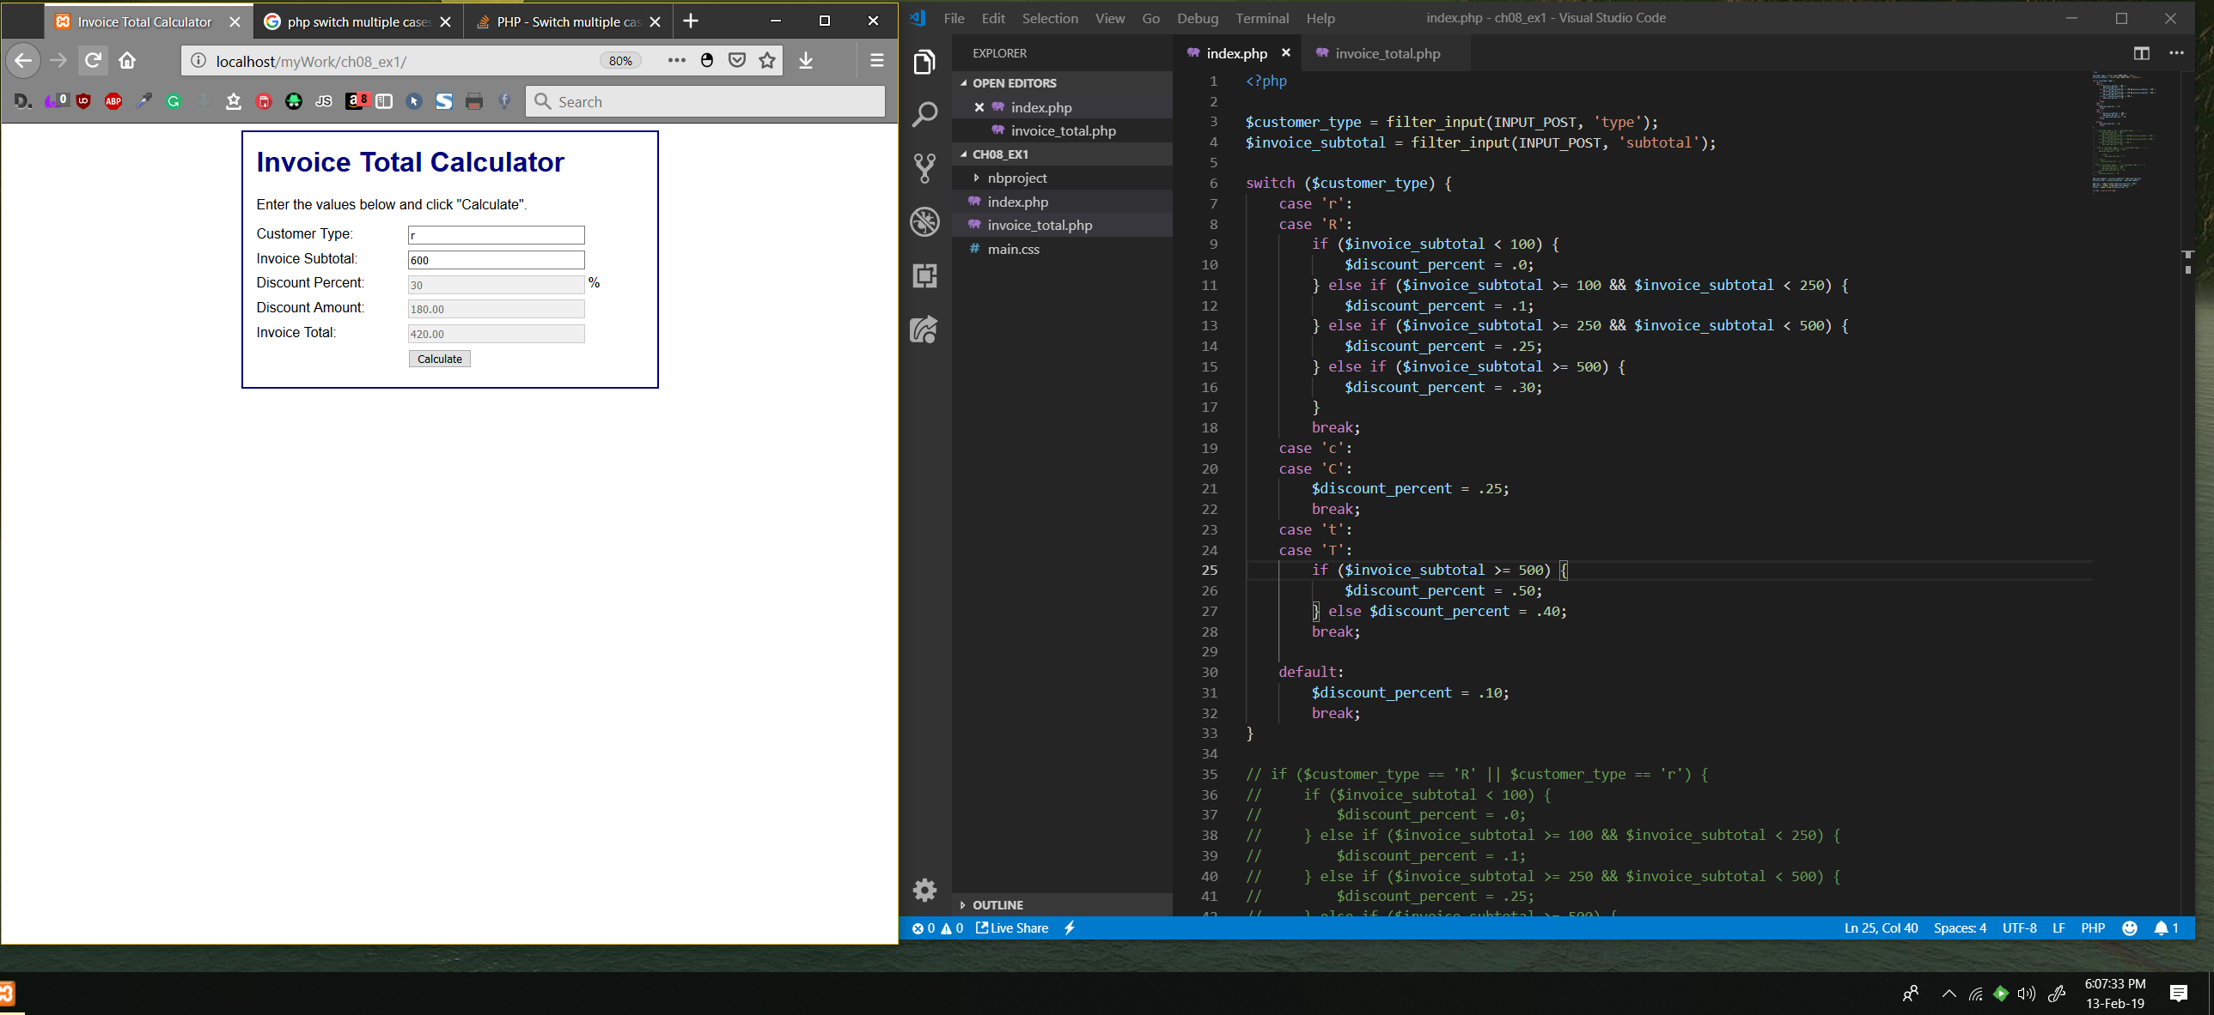

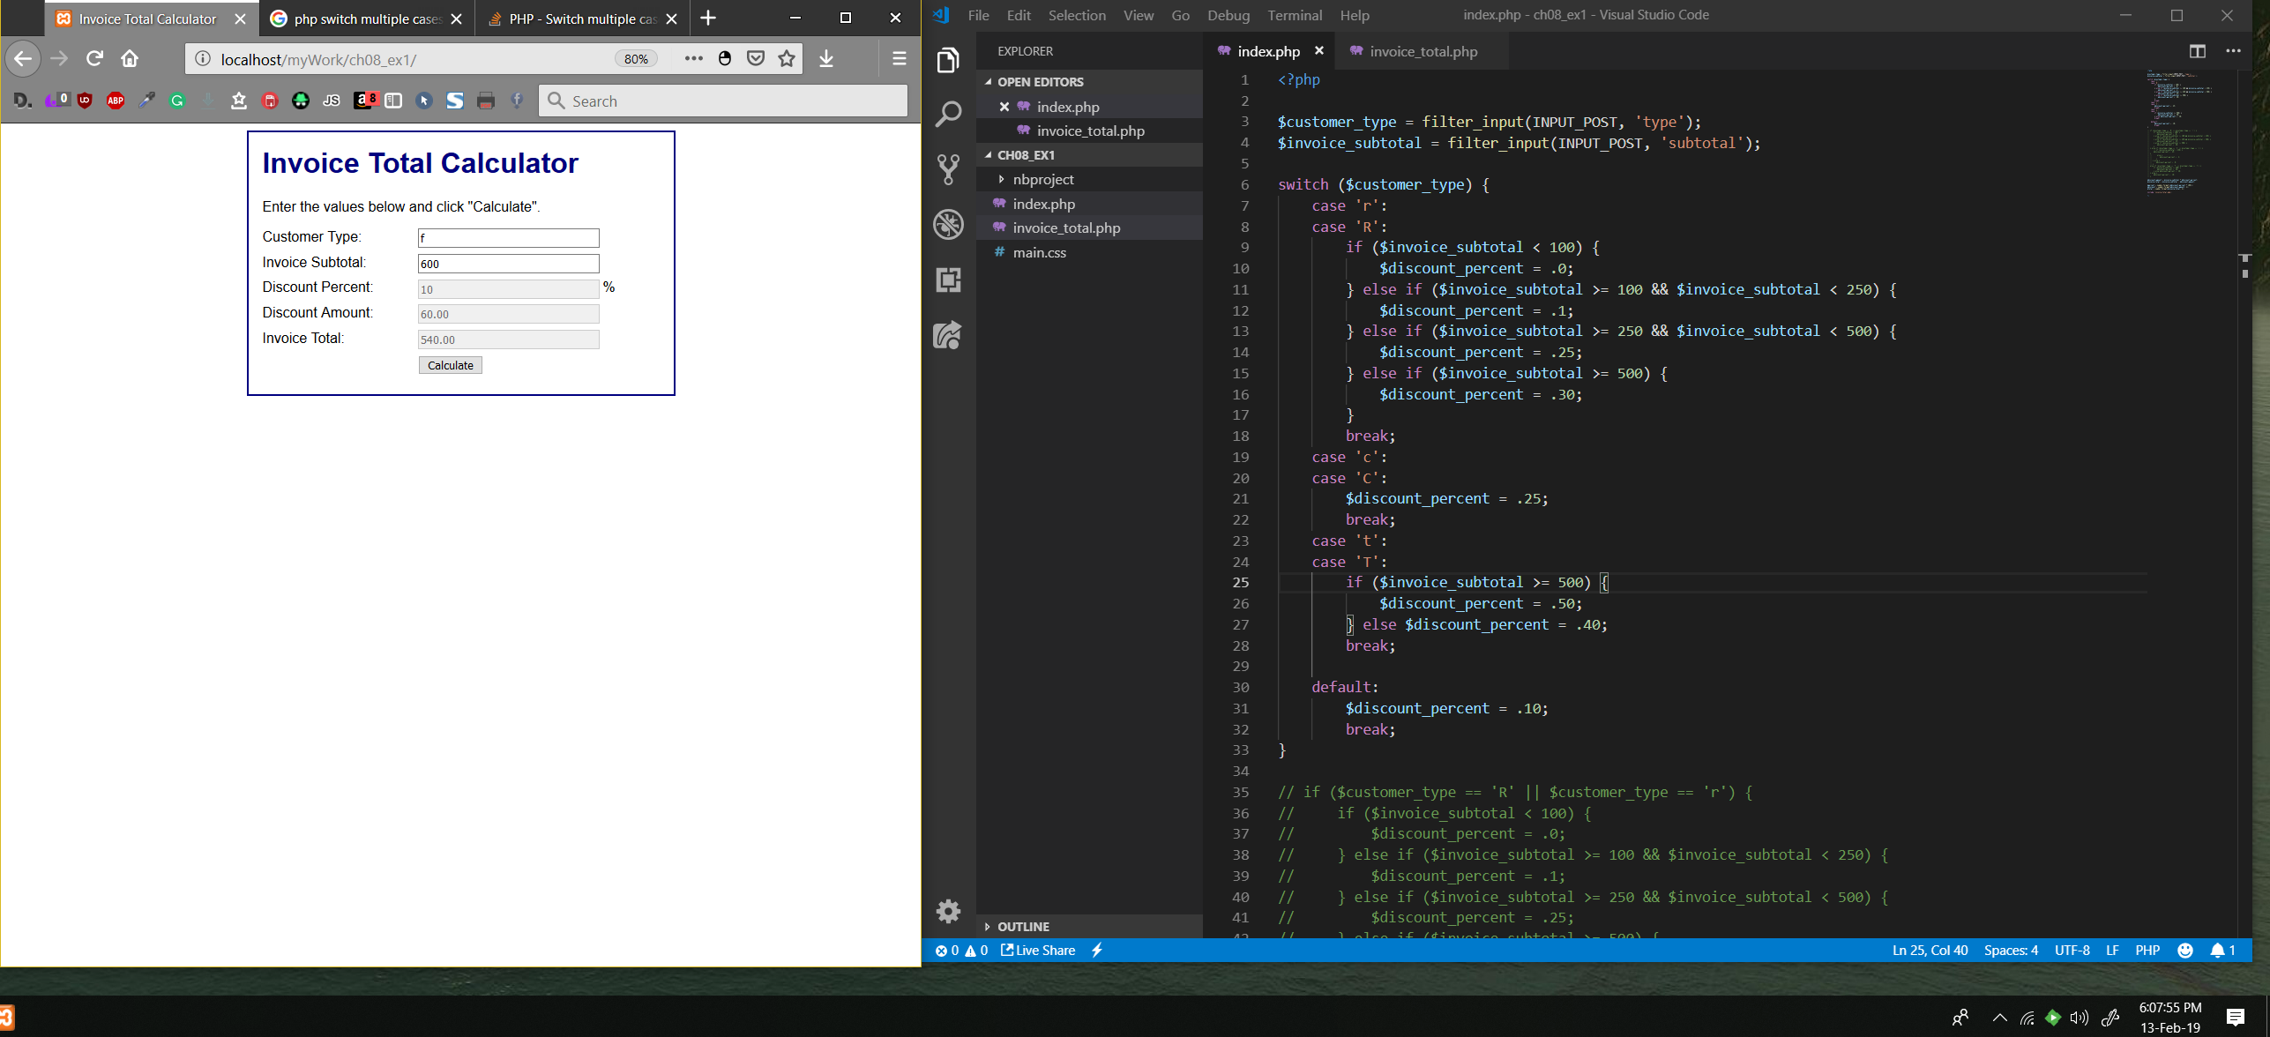

Book Exercise 8-2

1. Run the application in the ex_starts/ch08_ex2 directory.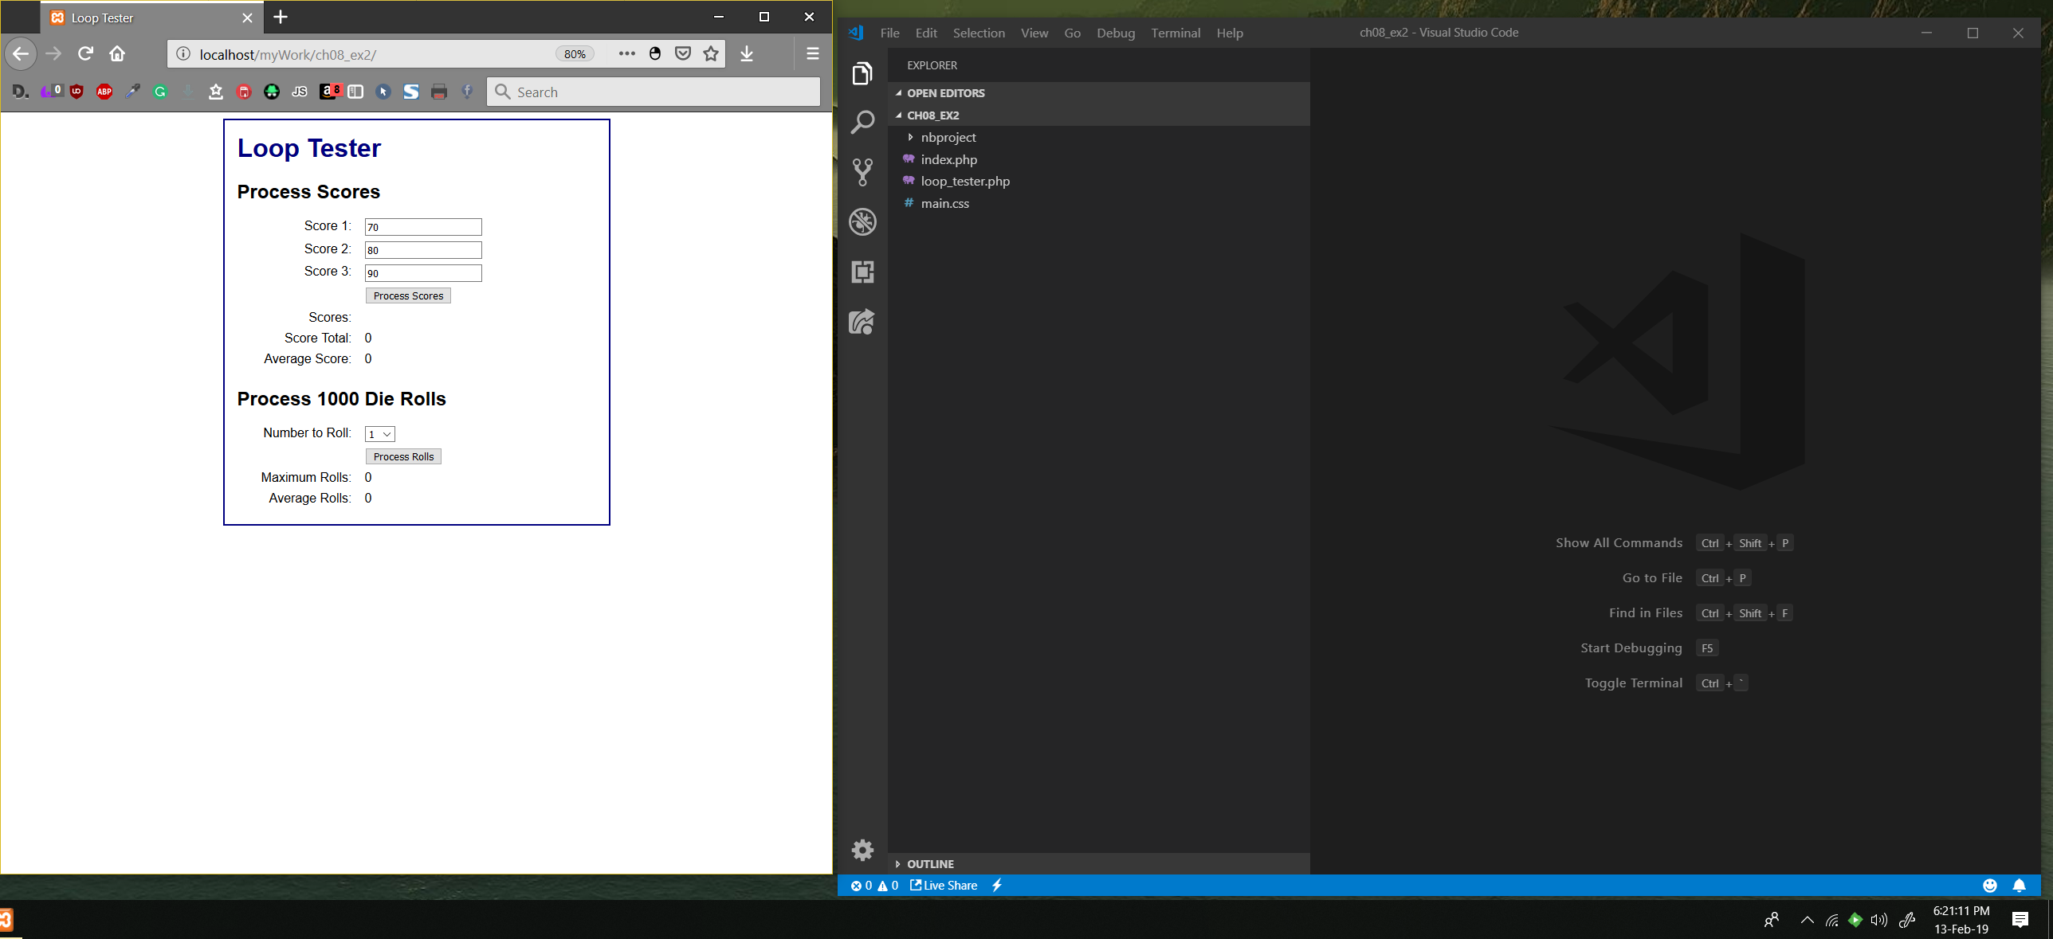

2. Click on the Process Scores button and note that it only displays the scores and doesn’t calculate the total or the average.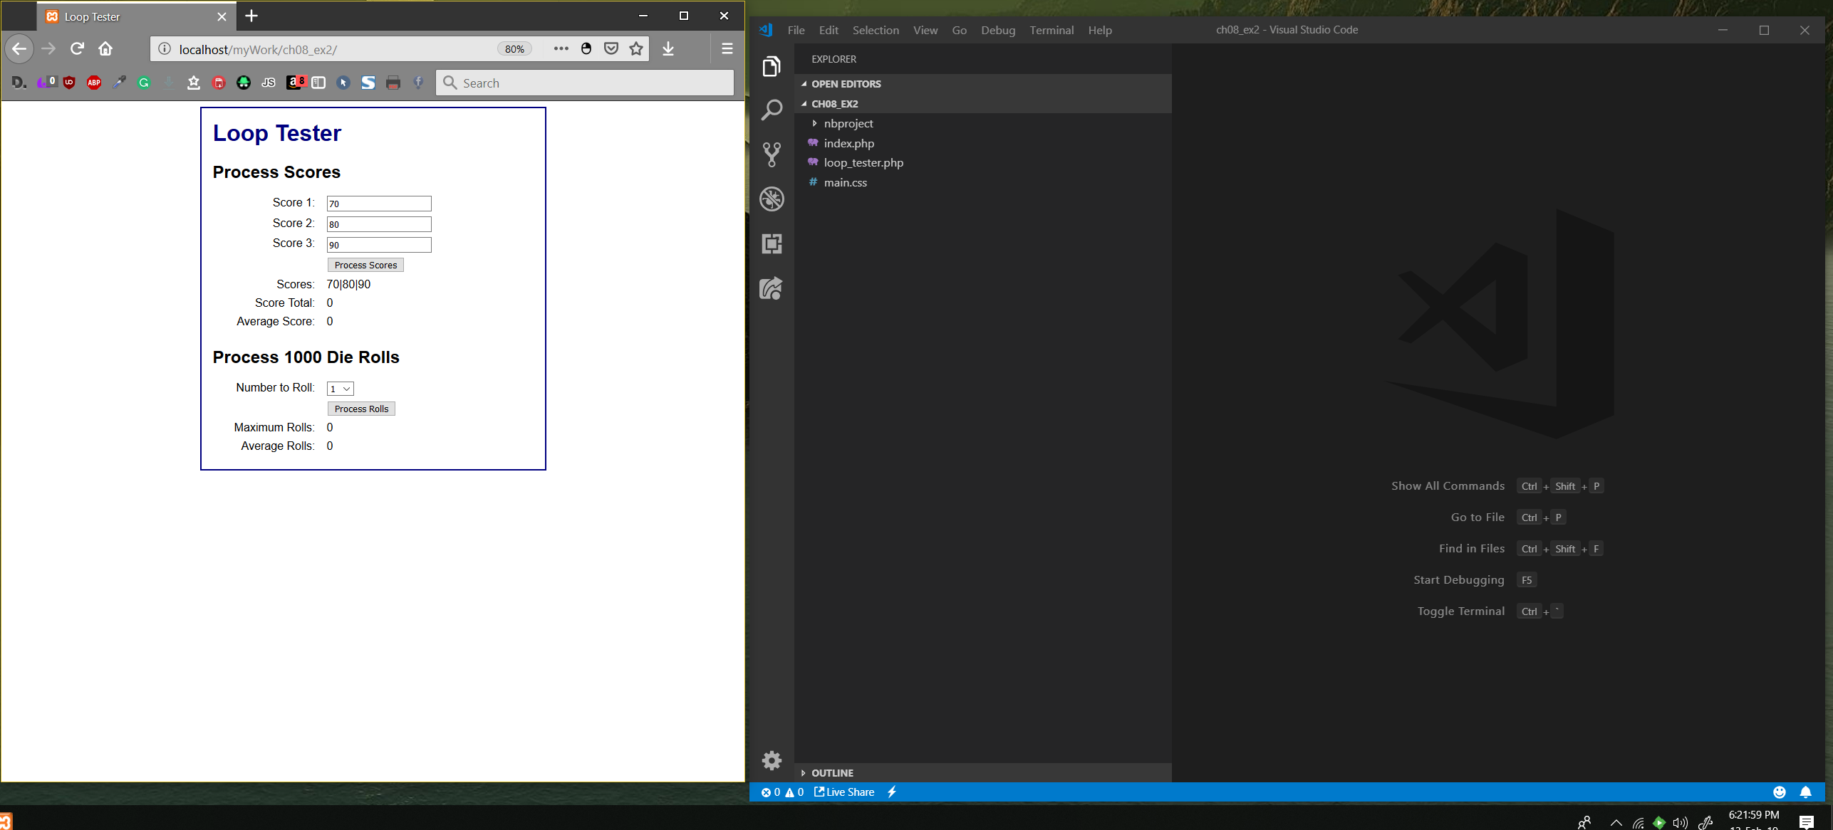

3. Click on the Process Rolls button and note that it displays the maximum and average number of rolls that it took to roll the specified number.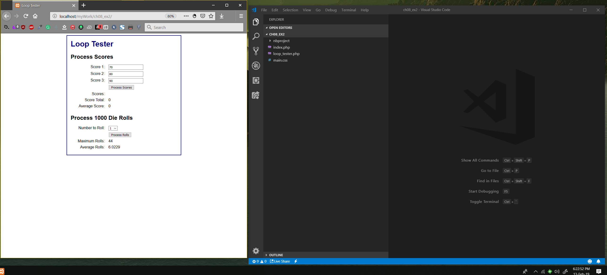

4. Open the index.php and loop_tester.php files for this application and review the code.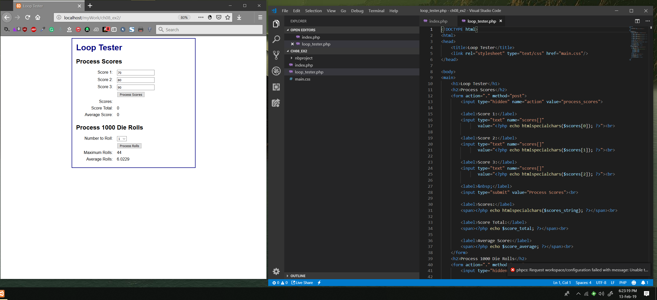

**Implement the score processing**5. In the index.php file, add code that calculates the score total. When you’re done, clicking the Process Scores button should display the correct total and average.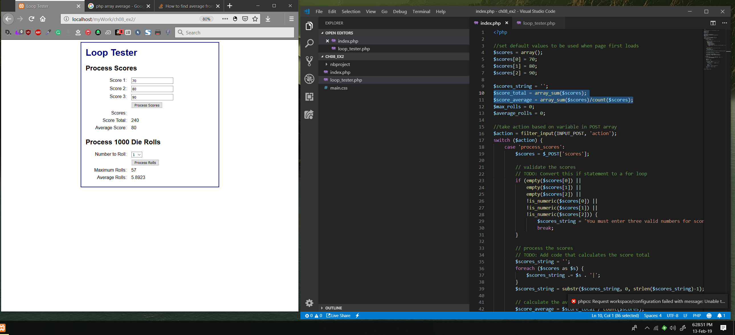

6. In the index.php file, use a for loop to validate the user entries instead of using multiple conditions in a hard-coded if statement.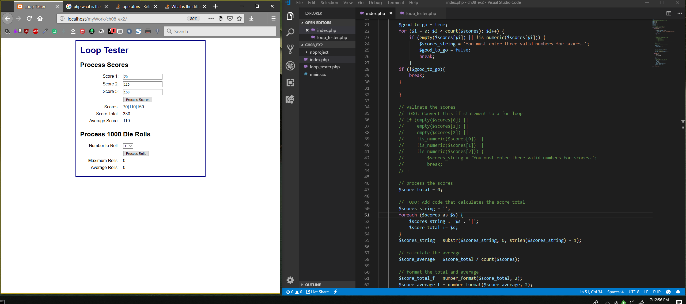

7. Test your changes to make sure they work correctly.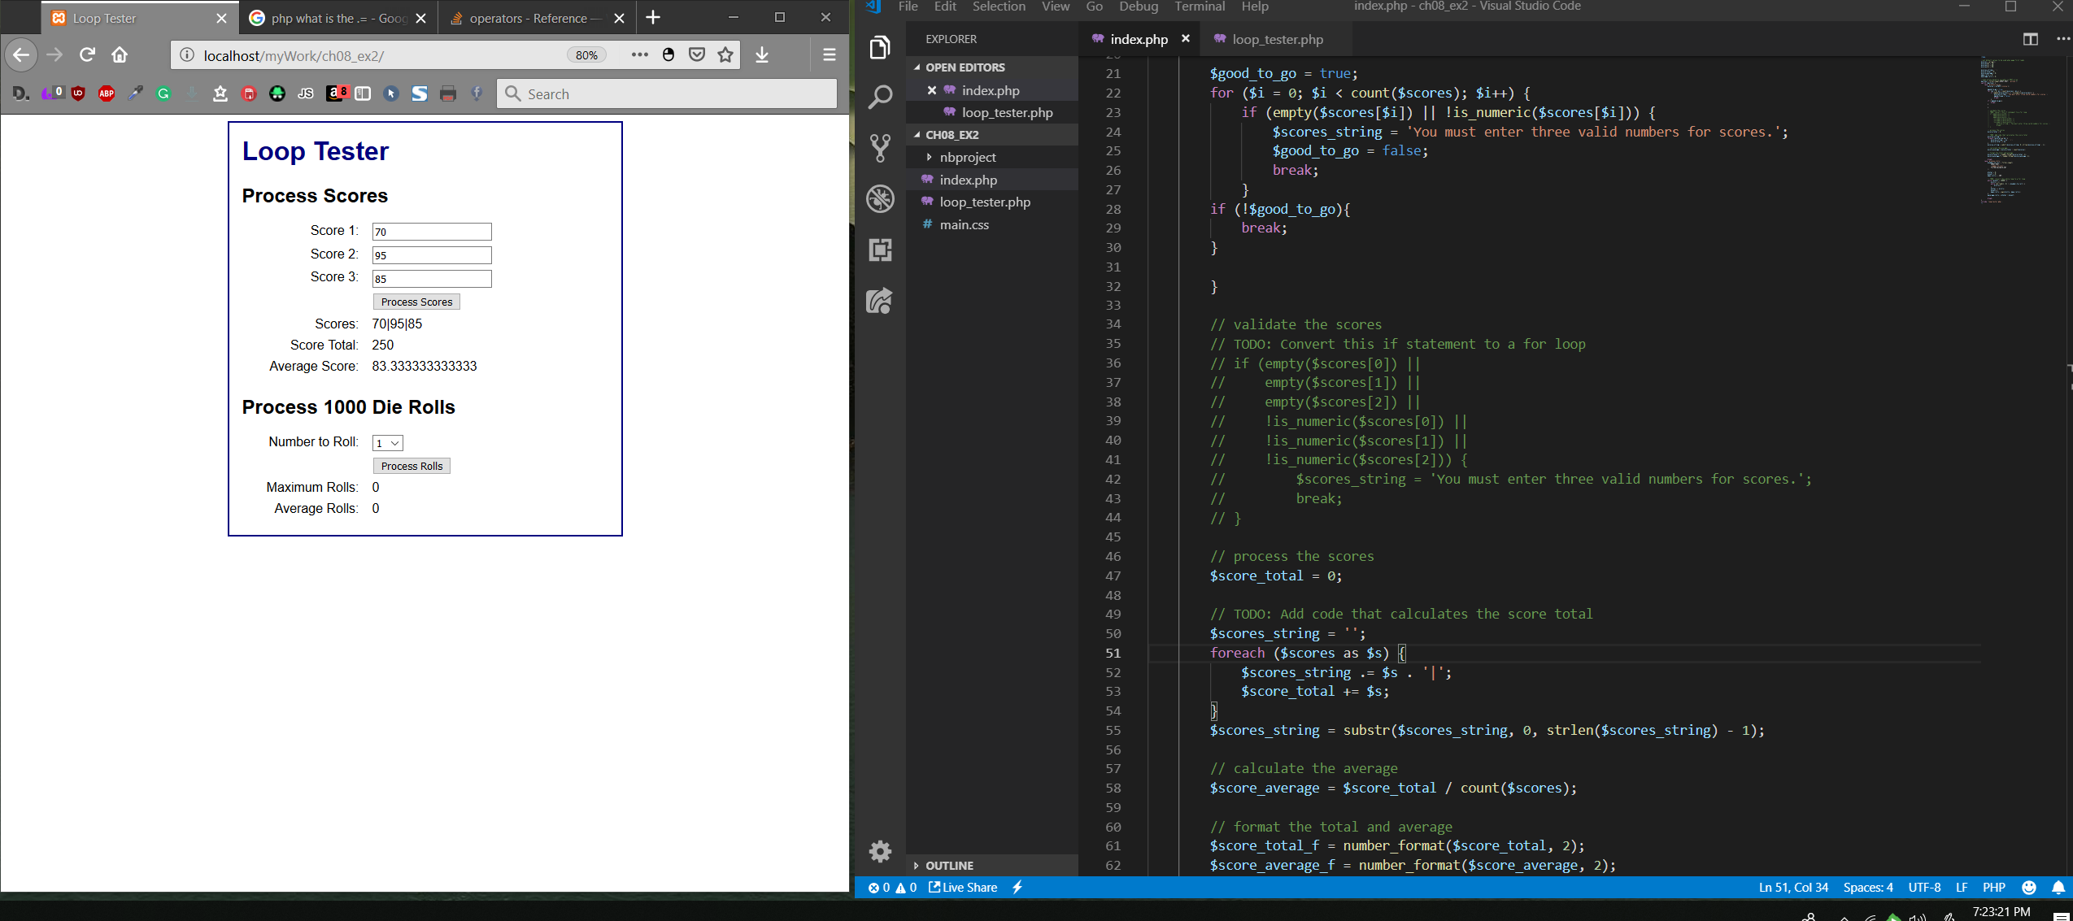

**Modify the roll processing**8. In the index.php file, modify the code that processes the rolls so it uses a for loop as the outer loop instead of a while loop.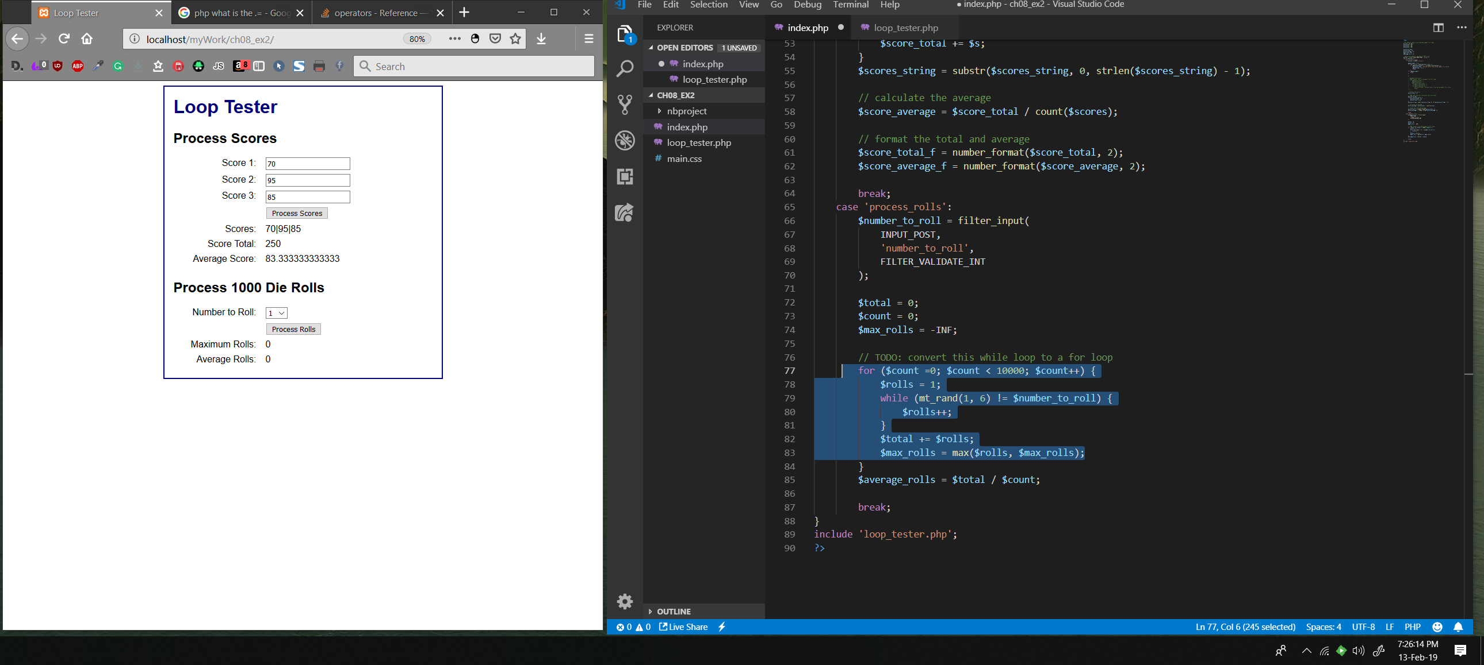

9. In the loop_tester.php file, use a for loop to display the <option> tags for the drop-down list instead of hard-coding six <option> tags.

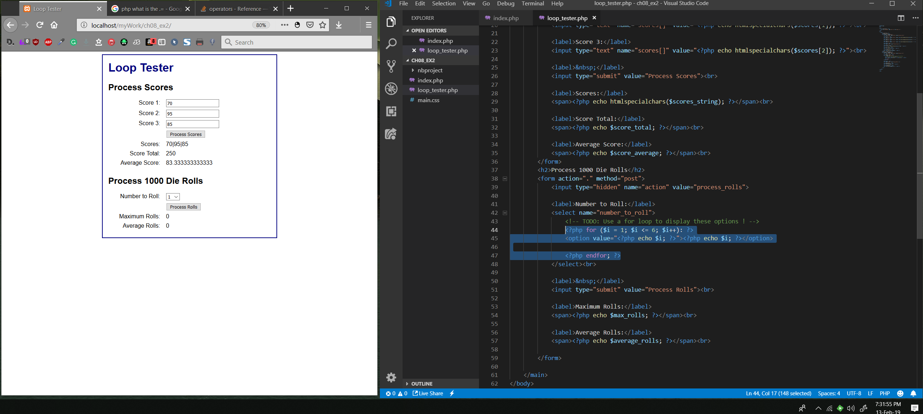

Not in the Book exercise

Create a page that is stylish and collects the user's name, hours worked in a week and the pay rate of the user.  Using the code, calculate and show the total pay for the employee with the assumption that anything over 40 hours is overtime time.  Overtime pay is time and a half, which means the base pay rate * 1.5.  Do not make this a simple black and white few pages, add style into it.  When you test it for the screen shots, do 2 paycheck calculations.  One calculation for someone between 10 and 19 hours and then someone at between 41 and 44 hours.  **There is the expectation that you will use the IF construct when doing the pay calculation.**

